Fiscal Regimes


February 2003
© 2003 Palantir Economic Solutions

Introduction

Countries are highly diverse in the manner in which they derive revenue from oil and gas projects. The systems they use to regulate and tax the petroleum industry are commonly referred to as the fiscal regimes. Many countries use different taxation systems for different areas such as onshore and offshore. In addition many have changed the systems over the years, sometimes instigating or removing special taxes and sometimes putting entirely new systems in to place for new blocks.
In many countries, particularly those running Production Sharing Contracts, the terms are negotiable and the economic viability of an asset may not be clear until the terms have been fully negotiated.
The motivations for a country in designing a fiscal regime are based on gaining as large a share of the total revenue without deterring companies from conducting exploration. This often means that they offer preferential terms for smaller fields or remote areas to ensure that they are commercially attractive to foreign or national oil companies.
The world’s fiscal regimes can be broadly divided into three systems:
- Royalty / Tax systems
- Production Sharing Contracts (PSCs or PSAs)
- Service Contracts

This document describes the basic structure of these contract types. In addition it describes the ways in which governments or state oil companies may opt to participate in a project.

Royalty / Tax Systems

Introduction
Most of North West Europe and North America is based on royalty / tax systems. Successful applicants for exploitation of a block are awarded a concession which is the right to drill and recover hydrocarbons for a specified period. Typically a concession will specify minimum obligations with regard to operating the block such as a certain number of wells to be drilled in a specified period.
In most cases the operating company does not own the mineral reserves but owns what is produced for the duration of the concession. The USA is almost unique in that land owners also own the mineral rights to that land.
Under concessions or royalty/tax systems the government derives revenue in three main ways:
- Bonuses
- Royalty
- Tax

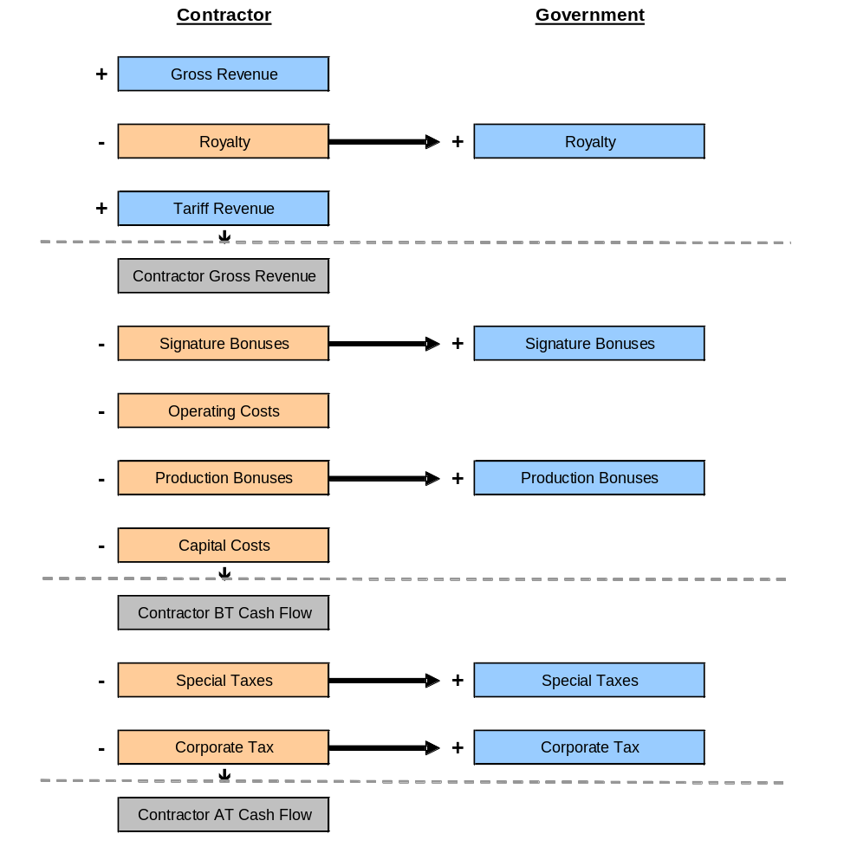

Bonuses
Bonuses are up-front cash payments and do not relate to actual revenue derived from hydrocarbon production. The most common kinds of bonuses are signature bonuses and production bonuses.
Signature bonuses are payable at the start of the contract, often before exploration begins. Production Bonuses are payable when production first starts. They are typically in the range MM$ 0.50 to MM$ 20 although they can be much greater in some cases. The giant Tengiz field in Kazakhstan is reputed to have had a signature bonus of more that MM$ 100.

Royalty
Royalties are a percentage of production revenue taken off the top. Typically the revenue is considered to be wellhead value i.e. gross revenue though sometimes it is taken to be the value at a particular facility or terminal. This effectively means that the royalty is based on net revenue i.e. gross revenue less transport costs.
Royalties will often work on a sliding scale based on daily production rates, annual volumes or cumulative volumes.
Many countries have gradually been lowering royalty rates and many like the UK and The Netherlands have scrapped them altogether in recent years.

A typical royalty schedule may be structured as follows:

Production | Royalty Rate
(bbl/day) | (%)
< 5,000 | 0%
5,000 – 10,000 | 3%
10,000 – 15,000 | 5%
15,000 – 25,000 | 7%
> 25,000 | 10%

The first 5000 bbl/day production is royalty free whilst subsequent incremental volumes are eligible for higher rates. There are three ways that systems such as this may apply:

Incremental
The first 5,000 bbl/day pays 0% royalty. The next 5,000 bbl/day pays 3% royalty and so on.

 | Tier 1 |  |  | Tier 2 |  |  | Tier 3 |  |  | Effect. Royalty
Prod. | Elig | Rate | Bal | Elig | Rate | Bal | Elig | Rate | Bal | Effect. Royalty
2,500 | 2,500 | 0% | 0 | 0 | 3% | 0 | 0 | 5% | 0 | 0.00%
5,000 | 5,000 | 0% | 0 | 0 | 3% | 0 | 0 | 5% | 0 | 0.00%
7,500 | 5,000 | 0% | 2,500 | 2,500 | 3% | 0 | 0 | 5% | 0 | 1.00%
10000 | 5,000 | 0% | 5,000 | 5,000 | 3% | 0 | 0 | 5% | 0 | 1.50%
20,000 | 5,000 | 0% | 15,000 | 10,000 | 3% | 5,000 | 5,000 | 5% | 0 | 2.75%
30,000 | 5,000 | 0% | 25,000 | 10,000 | 3% | 15,000 | 15,000 | 5% | 0 | 3.50%

Step
The field pays 0% royalty if production is less than 5,000 bbl/day. If production is between 5,000 and 10,000 then royalty is payable at 3% on all production.

Production | Effective Royalty
2,500 | 0%
5,000 | 0%
7,500 | 3%
10000 | 3%
20,000 | 7%
30,000 | 10%

Interpolation
As in the first two methods the field pays 0% royalty up to 5,000 bbl/day. Between 5,000 and 10,000 a straight line interpolation is performed to get a rate between 0% and 3%
Production | Effective Royalty
2,500 | 0%
5,000 | 0%
7,500 | 1.5%
10000 | 3.0%
20,000 | 6.0%
30,000 | 10.0%

Tax
In the simplest royalty/tax systems taxation is simply based on standard corporate tax rates. However most countries have one or several special taxes designed to derive additional revenue from hydrocarbon reserves.

Special Taxes
Some examples of special taxes are:
UK PRT
Petroleum Revenue Tax is a tax based on production revenues with special allowances for early years of production and threshold production volumes.
Netherlands SPS
State Profit Share is a tax that creates unique complications due to the mutual deductibility with other taxes.
Faroe Islands SHT
Special Hydrocarbon Tax is a tier based tax based on the Before Tax Internal Rate of Return (ROR / IRR). Beyond specified rates of return the tax rate goes up.

Corporate Tax
Corporate tax is generally the final deduction to give total After Tax Cash Flow.

Before tax calculation is usually equivalent to…
Gross Revenue – Royalty – Bonuses – Opcosts – Capex

Deductions
It is normal for gross revenue to be taxable with specified deductions. These deductions are usually:
- Royalty
- Bonuses
- Opcosts
- Capital Depreciation

Unused deductions can usually be carried forward to subsequent years. There may be a limit on the number of years that the unused deductions may be carried forward. In addition it is common for unused deductions to be carried forward with an uplift.

Depreciation
The definition of the way in which Capital may be depreciated for tax deduction is highly dependant on the fiscal regime. In most regimes different capital types are depreciated in different ways. Some common methods for capital depreciation are:
- Write-Off
- Straight Line (n years)
- Depletion (Unit of Production – UOP)
- Declining Balance
- Custom Time/Value Pair arrays
Typically exploration capex will be written-off whilst other capital types will be depreciated over longer periods. In some cases a percentage of one capital type such as development drilling may be partially eligible for a tangible depreciation pool and partially eligible for intangible depreciation.

Production Sharing Contracts

Introduction
Production Sharing Contracts (PSCs), also known as Production Sharing Agreements (PSAs) are common in Africa, South America and Asia. They are fundamentally different to a Concession in that the contractor does not actually own the produced oil. Instead the contract gives them the right to operate the field in return for a specified share of production.
They are popular with many governments due to the amount of control they are able to have over individual fields. The contracts can be structured to make small fields commercially viable and limit the contractor share of large, profitable fields.
PSCs tend to be far more complicated than Royalty / Tax regimes and often entail extensive calculations.

First Tranche Petroleum & Royalty
Many PSCs have either a Royalty or FTP which is taken off gross revenue before Cost Recovery. The royalties work in the same way as for Concessions. FTP is different in that like Profit Oil it may be divided between contractor and government. It is common to use the fraction from the Profit Split calculation to divide the FTP.

Cost Recovery
Remaining revenue after FTP is eligible for Cost Recovery. This is the process within a PSC that enables the contractor to recover costs.
A PSC will define an order in which costs must be recovered. This is commonly as follows:
- Opcosts
- Development Capex
- Exploration Capex
Available revenue is used to recover the costs with unrecovered balances carrying forward to subsequent periods. On the following example opex and opex unrecovered balance must be recovered first.

Revenue | Costs |  |  | Opex
Revenue | Expl Cap | Dev Cap | Opex | Revenue | Recovery | Balance
0 | 100 | 0 | 10 | 0 | 0 | 10
60 | 0 | 50 | 10 | 60 | 20 | 0
60 | 0 | 50 | 10 | 60 | 10 | 0
60 | 0 | 0 | 10 | 60 | 10 | 0
60 | 0 | 0 | 10 | 60 | 10 | 0
60 | 0 | 0 | 10 | 60 | 10 | 0
60 | 0 | 0 | 10 | 60 | 10 | 0
60 | 0 | 0 | 10 | 60 | 10 | 0
60 | 0 | 0 | 10 | 60 | 10 | 0
60 | 0 | 0 | 10 | 60 | 10 | 0
60 | 0 | 0 | 10 | 60 | 10 | 0

Remaining revenue may then be used to recover Development Capex and finally Exploration Capex.

Development Capex |  |  | Exploration Capex
Revenue Available | Recovery | Balance | Revenue Available | Recovery | Balance | Remaining Revenue
0 | 0 | 0 | 0 | 0 | 100 | 0
40 | 40 | 10 | 0 | 0 | 100 | 0
50 | 50 | 10 | 0 | 0 | 100 | 0
50 | 10 | 0 | 40 | 40 | 60 | 0
50 | 0 | 0 | 50 | 50 | 10 | 0
50 | 0 | 0 | 50 | 10 | 0 | 40
50 | 0 | 0 | 50 | 0 | 0 | 50
50 | 0 | 0 | 50 | 0 | 0 | 50
50 | 0 | 0 | 50 | 0 | 0 | 50
50 | 0 | 0 | 50 | 0 | 0 | 50
50 | 0 | 0 | 50 | 0 | 0 | 50

Cost Recovery Limit
In many fiscal regimes there is a limit on how much of the gross revenue may be used for cost recovery (commonly 50%). This is to ensure that there is profit oil available for Profit Split.

Excel Cost Oil / Gas
In cases where a cost recovery limit applies there may be an excess cost oil or gas split. Of the revenue eligible for cost recovery, anything unused by the cost recovery process may be split between contractor and government, usually using the split calculated for profit split.

Profit Oil
The remaining revenue after Cost Recovery is called Profit Oil and it is this that carries into the Profit Split calculation.

Profit Split
The profit oil is split between contractor and government according to a schedule of rates. There are as many ways of doing profit splits as there are PSCs and some regimes such as Algeria use a variety of different methods depending on the area and contract.
Some common methods include:

Simple Split
The profit oil is just divided between contractor and government based on single split e.g. 60 – 40 government contractor.

ROR Split
The split may be based on the Rate of Return for cash flow from the previous period. In some regimes a profit oil is assumed based on the previous periods split in order to calculate the ROR. In other cases a Notional Tax is calculated and included in the cash flow calculation needed.

Production Split
Probably the most common method is to split profit oil based on production. The same methods as for Royalty may apply with a tiered array of production – split values.

Production | Contractor | Government
bbl/day | % | %
< 5000 | 40 | 60
< 10000 | 30 | 70
< 20000 | 20 | 80
> 20000 | 10 | 90

R Factor Splits
Many countries calculate an “R Factor” that is used to derive the profit split. The R Factor can be calculated in more than one way but is usually defined as follows:
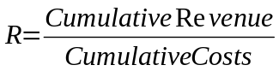

R Factors are commonly used in South American PSCs.

Contractor Caps
In Algeria there the Contractor share of gross revenue (Cost Recovery + Profit Oil) may not exceed 49% of total field revenue. Under this regime either or both the Cost Recovery and Profit Oil may be limited by this percentage cap.
The application of this cap may be more complex than 49% in all periods. There is an accelerated recovery period for the first five years production during which the cap is an array equal to 65 – 70 – 65 – 60 – 49 %. However, these rates apply to cumulative entitlement over cumulative revenue and thus eventually equalize in the fifth year.

Tax
Tax tends to apply in the same way as for concessions. It is quite common for there to be no applicable taxes in a PSC.

Cash Flows
Evaluating a PSC may require that multiple Cash Flows be calculated. This shown diagrammatically in greater detail towards the end of this document. A PSC tends to have a fairly complex web of working interests due to the involvement of multiple foreign partners, NOCs, JOBs and Governments.
The Working Interest structure may be:
- Project
- Contractor
  - Foreign Partner 1
  - Foreign Partner 2
  - Foreign Partner 3
  - National Oil Company
- JOB
- NOC Government

The Company and Government Cash Flows will include the following components:

 | Contractor |  | Government
+ | FTP | + | Bonuses
+ | Cost Recovery | + | FTP
+ | Excess Cost Oil | + | Royalty
+ | Profit Oil | + | Excess Cost Oil
+ | Tariff Revenue | + | Profit Oil
- | Opcosts | + | Tax
- | Capital Costs
- | Bonuses
- | State Carry
- | Tax

State Participation
Under a PSC the state may retain the right to participate in the project. IN essence they behave like just another partner except paying their share of costs and receiving their share of revenue. However, the state is normally “carried” through the exploration and development phase. This means that the foreign partners pay their share of exploration and development and the state pays it back with interest when the project starts generating revenue.
State participation is usually achieved through a National Oil Company (NOC). In addition a Joint Operating Bond (JOB) may be in effect. The difference between the two is that under a JOB, a percentage of revenue is taken off the top whereas under NOC participation they behave more like a foreign partner.

PSC Structure

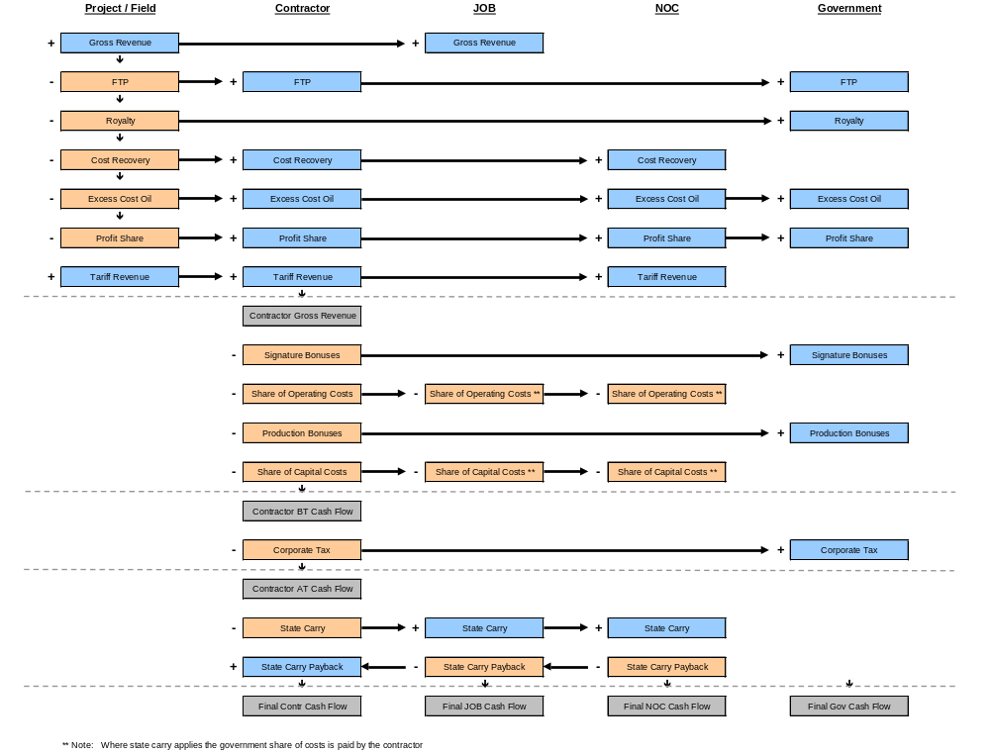

Service Contracts
Service contracts are in use in countries such as Saudi Arabia. En effect the foreign oil company simply acts as a service company and is paid a fee for operating the asset.

